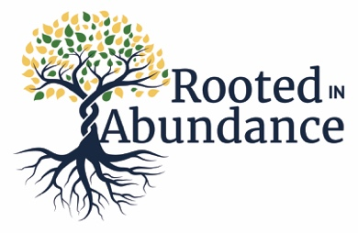
They shall be like a tree planted by water, sending out its roots by the stream. It shall not fear when heat comes, and its leaves shall stay green; in the year of drought it is not anxious, and it does not cease to bear fruit. - Jeremiah 17:8

Dear Siblings and Brothers and Sisters in Christ,

The phrase I say most often at St. Alban’s is “Thank you.” Thank you for being you. Thank you for bringing all of who you are to this community, your passions, your gifts, your questions, and all your perfect imperfections (to borrow a line from the great John Legend).

I also tend to close my emails with the phrase “with gratitude.” It’s a habit I picked up when I was translating and editing Buddhist lectures, though a more literal translation for the Chinese characters we used is “feeling (the) grace (感恩).”

Grace is what I feel when I walk into the church on Sunday mornings and see the light streaming through the windows and hear Dottie practicing on the organ. Grace is what I feel when I see familiar faces and new ones, or familiar faces in new settings, like the Youth Mission Trip! Grace is what I feel when I walk out of the Assembly Room on Saturday afternoons after workshops like The Austin Story that point us toward living the gospel and being good news. Grace is what I feel when I joyfully proclaim, “Go in peace to love and serve the Lord!”

On a more practical level, grace is what I feel when I look at our financial statements each month. We went into this year with a projected deficit for our operating budget, and I was really worried about our ability to pay our staff, run our programs, and keep up with the maintenance of our buildings. We have a very lean budget, and it would’ve been hard to make cuts. Thanks to your generosity, we are in a better place than we expected. Instead of looking at what we lack, I’ve been able to focus on the abundance of fruits we bear and can share. Instead of stressing out about how to survive, I’ve been dreaming about how we can thrive.

So, as you consider your 2024 budget and your plans to support causes and places near and dear to your heart, I hope St. Alban’s will be one of your priorities. Help us out by submitting your pledge by Sunday, Nov. 19. Make a pledge for the first time! Consider increasing your pledge by 10%! If your circumstances change, just let us know. You can make your giving commitment online or with a physical pledge card (available in person soon!).

Thank you. Thank you. Thank you. You are part of the abundance here; help us share God’s abundance with the world.

With gratitude,

Peggy
