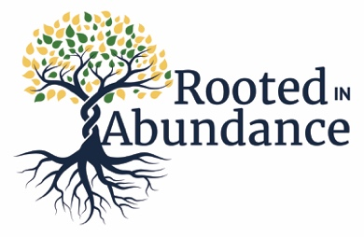
They shall be like a tree planted by water, sending out its roots by the stream. It shall not fear when heat comes, and its leaves shall stay green; in the year of drought it is not anxious, and it does not cease to bear fruit. - Jeremiah 17:8

It is the unofficial “church season” of Stewardship. It occurs yearly in the fall during Ordinary Time and interestingly right around Halloween!

Our stewardship theme this year is Rooted in Abundance. Just as trees share nutrients with each other and keep each other safe from threats to their wellbeing, so too are we connected at St. Alban’s. We work together, we feed each other, we come to experience God together in the Eucharist on Sundays.

The Prayer network at St. Alban’s is like the leaves of a mighty oak. They whisper to each other when we are in need. Our church community is remarkable in the many ways that we show love and concern for each other. Most recently we came together to help a family say goodbye to a loved one. I was overwhelmed with the cooperation and coordination that showed itself on
behalf of the family. It is not this way everywhere.

This church is gifted in expressing love. You are gifted as individuals, and you are dynamite when your gifts come together for good. There is so much concern, caring and abundance here at St. Alban’s and so much that I am personally grateful for: the usher who smiles and remembers each Sunday that I want a printed copy of the sermon for my husband; the faithful parishioners who treat us to goodies to go with our coffee after church; the parishioner who faithfully weeds the church grounds; the talent, camaraderie and caring I have enjoyed in the choir.

I appreciate the opportunity to serve as senior warden and to grow and learn from the well thought out sermons that we hear each week. Being surrounded by the love, fellowship and hospitality of St. Alban’s means that I will pledge a little more this year and give of my time as needed so that I can help extend what we have here at St. Alban’s to the community around us.

Dream big! It’s our opportunity to share something very special with others and to show our appreciation for all the good things we enjoy and cherish here at our amazing church home.

Please consider making a pledge if you have not done so in the past. It is so helpful in planning a church budget if the income anticipated is known, even approximately. If you have pledged in the past, please add a bit as you are able. Let’s see what we can accomplish at St. Alban’s with God’s abundance!

Many thanks,

Rosemary Cole
